St. Malachy Middle/High School Retreat

At the request of parents and teens we are once again able to welcome the NET missionaries back to St. Malachy by a generous donation from the St. Malachy Security Ministry. The retreat will be on May 3rd from 4:30pm - 8:30pm. During the retreat, young people experience group activities, talks, skits, small group discussions, prayer, and music, giving youth a dynamic yet prayerful encounter with Christ. This retreat is a great experience for them to make new friendships and learn more about their faith. They are encouraged to bring a friend. Registration is required. Please register asap so we can order shirts.

When: Tuesday, May 3, 2022
Time: 4:30pm – 8:30pm
Where: St. Malachy Currier Center
*Dinner will be provided*

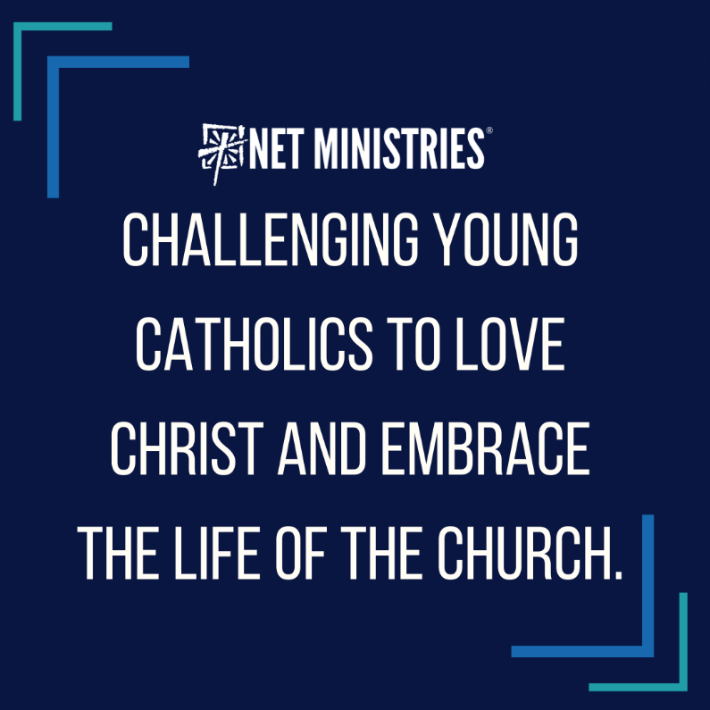

------------------------------------------------------------------------------------------------------------------------------------------
Student Name:_______________________________________________________________
Parent(s) Name:______________________________________________________________
Email Address:________________________________________________________________
Emergency Contact during retreat ________________________________________________
Emergency number of contact during retreat________________________________________
Food Allergies:_________________________________________________________________
Shirt Size:_____________________________________________________________________
MEDICAL TREATMENT RELEASE FORM

To Whom It May Concern:

As parent/guardian, I do hereby authorize the treatment of a qualified and licensed physician of any condition which, in the opinion of the physician, is deemed necessary and appropriate. This authority is granted only after a reasonable effort has been made to reach me.

Name of Minor: Relationship to you

Reason for which release is intended:

Address of Minor: City:

Emergency Phone(s): Emergency Contact Person:__ ________

Family Physician: Phone:

Physician Address: City:

List allergies, medication, contract, or other pertinent comments:

Health Insurance Data:

Company: Policy:

Group: Contract:

I further authorize the person who presents the minor to sign the Acknowledgment of Receipt of Notice Privacy Rights that may be presented by the physician or health care facility.

This authorization is completed and signed of my own free will with the sole purpose of authorizing medical treatment deemed necessary and appropriate by the treating physician.

Date: Signed:
(Parent or Guardian)

PSI/MedRel/05-94
HAPS-March 2004

☐ medication needs to be dispensed. Contact the religious education office for the Release for Dispensing of Medication form.

